GIP Kruispunt

# Lusdetectie

# Colpitts oscillator

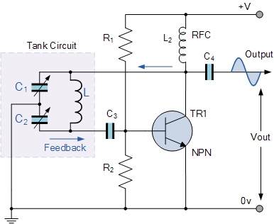

$C= \frac{C_{1} * C_{2}}{C_{1 }+ C_{2}}$

$$F_{r}=\frac{1}{2π\sqrt{LC}}$$

Voorbeeld:

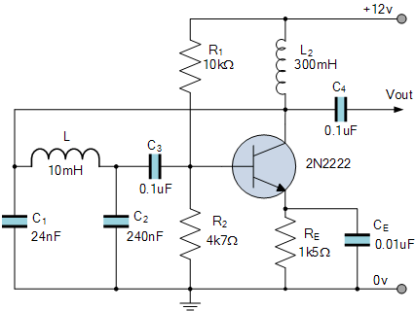

$C=\frac{24nF * 240nF }{24nF+ 240nF}$ = 21,84nF 14

$F_{r}=\frac{1}{2π\sqrt{0,01 *21,84nF}}$ = 10,8kHz

$C=\frac{15nF * 220nF }{15nF+ 220nF}$ = 14nF $F_{r}=\frac{1}{2π\sqrt{0,01 *14nF}}$ = 13,451kHz

Link: <https://www.electronics-tutorials.ws/oscillator/colpitts.html>

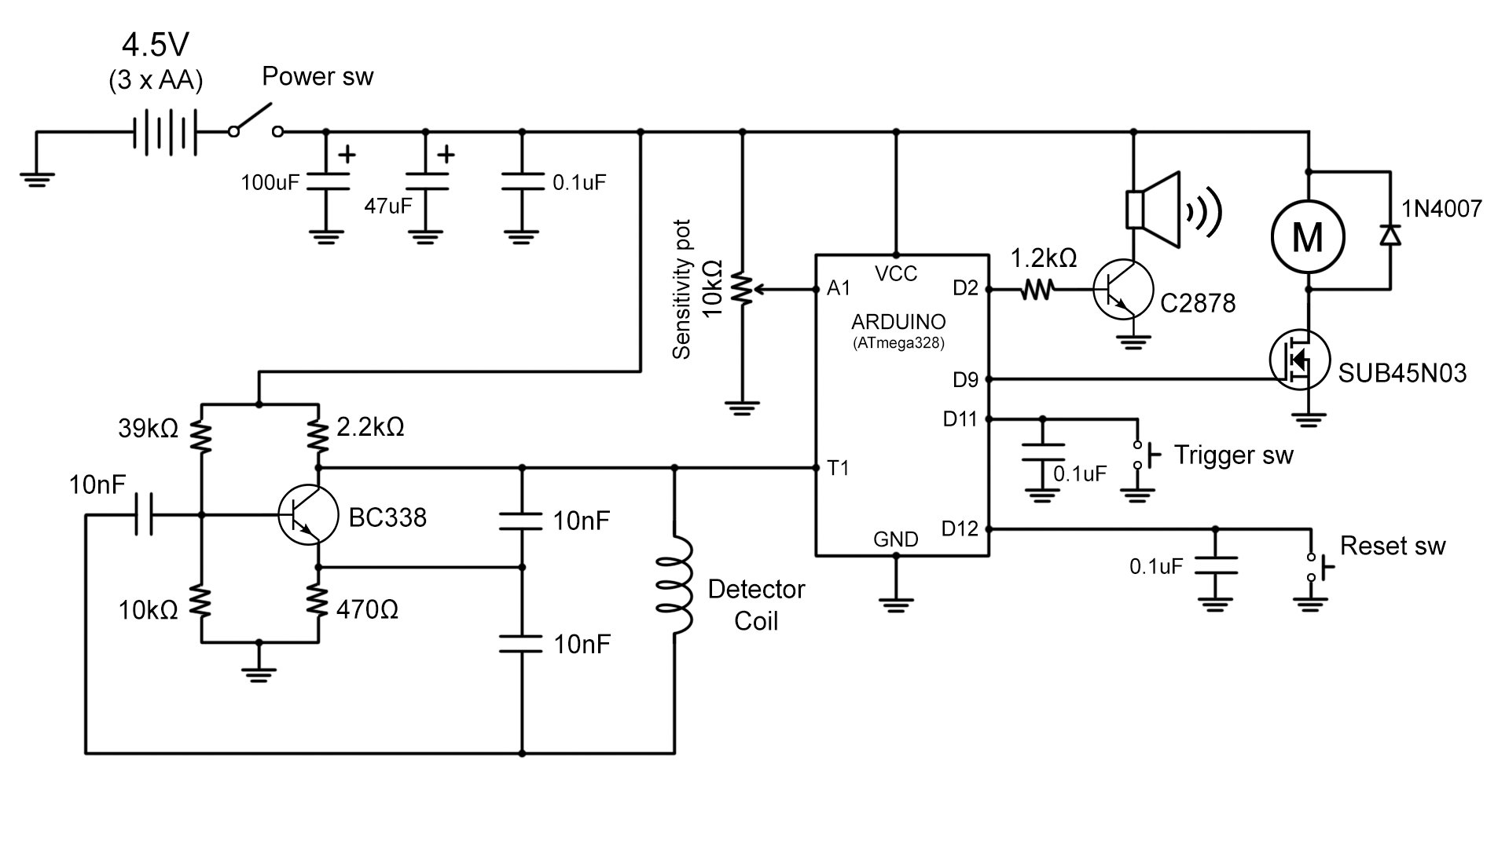

Link: https://www.allaboutcircuits.com/projects/metal-detector-with-arduino/